## Simple example

Just to explain how it works, we will show a small example. This is merely to show how the diverse methods of implementing work in case you are already familiar with PLC programming.

## Start

When you click “Add” you will start a new program. This program starts with an empty line and is called “SoftPLC1” if it is the first program you start. If you click “Rename” you can give it a distinctive name, which will pay off when you have a lot of PLC programs in your system (see Figure 8‑2).

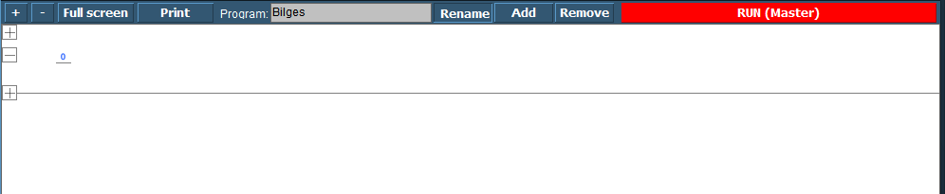

Figure 8‑2: SoftPLC Rename

Once you renamed it, you can go on with the program. For those familiar with PLC programming, you will recognize this as a ladder diagram. With the “+” you can add lines before or after and with “–“ you can remove the line.

We start this program with a bilge pump, which should run when a certain bilge alarm is high. When you click at the left side of the “0” a new pop-up appear with choices (see Figure 8‑3).

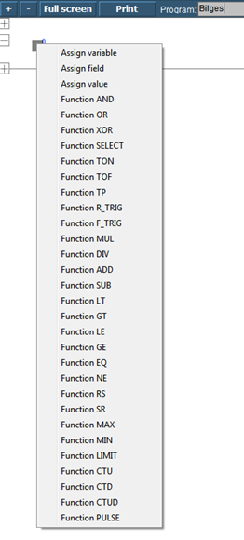

Figure 8‑3: SoftPLC pop-up

|  |  |
| --- | --- |
| Function | Explanation |
| Assign Variable | Assign a variable that you defined in the program |
| Assign Field | Assign a FT NavVision© field |
| Assign Value | Assign a value |
| Function OR | Logic OR |
| Function XOR | Exclusive OR |
| Function SELECT | Select |
| Function TON | Timer ON |
| Function TOF | Timer OFF |
| Function TP | Pulse Timer |
| Function R-TRIG | Rising Trigger |
| Function F-TRIG | Falling Trigger |
| Function MUL | Multiply |
| Function DIV | Divide |
| Function AD | Add |
| Function SUB | Subtract |
| Function LT | Lesser Than |
| Function GT | Greater Than |
| Function LE | Lesser or equal |
| Function GE | Greater or equal |
| Function EQ | Equal |
| Function NE | Not Equal |
| Function RS | Reset before Set |
| Function SR | Set before Reset |
| Function MAX | Maximum |
| Function MIN | Minimum |
| Function LIMIT | Limit |
| Function CTU | Up Counter |
| Function CTD | Down Counter |
| Function CTUD | Up-Down Counter |
| Function PULSE | Pulse |

Table 8‑1: Add table

We choose for “Assign Field” to assign the Bilge Alarm as a trigger (see Figure 8‑4). Now we get into the FT part of the SoftPLC. You’ll get the FT NavVision© field dialog box where you can choose the appropriate field (see Figure 8‑4). After choosing the field the PLC line will look as in Figure 8‑5

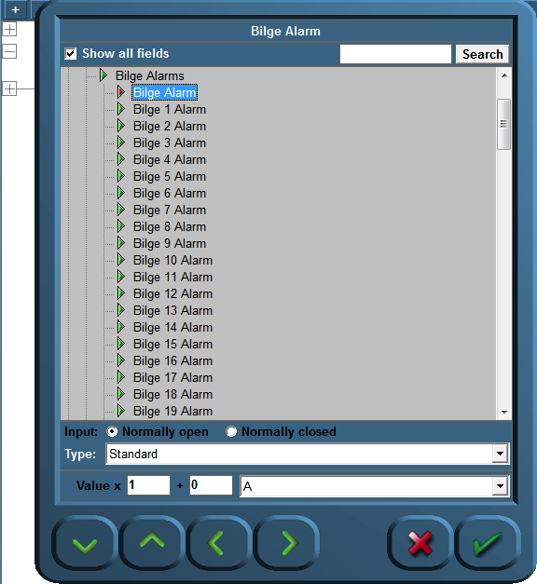

Figure 8‑4: SoftPLC Assign Field

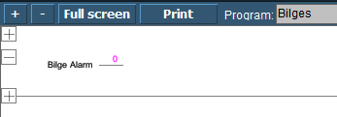

Figure 8‑5: SoftPLC first Line

We do the same at the right side of the “0” but this time we choose the Bilge Pump. We end up with a line like in Figure 8‑6.

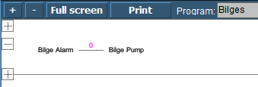

Figure 8‑6: SoftPLC First Line_2

So now when you press “Run” the program will run and check the bilge alarm over and over. Once it gets high, the connection in the line gets high (1) and the Bilge Pump starts running until the alarm is not high anymore.